**CSC 335 Data Communications and Networking**

**Getting Started with Packet Tracer**

Name: _____Tyler Prehl______________________________

Date: _______6/17/21______________________________________

**1. Goal and Deliverables**

Getting familiar with Packet Tracer.

Please answer all questions in red and attach required screenshots to this lab report and then submit it to D2L.

**2. Software: Packet Tracer**

**2.1 Packet Tracer**

Cisco Packet Tracer is an innovative network simulation and visualization tool, which will help you practice your configuration skills and see the results from your desktop or mobile devices. You can use the Packet Tracer to:

* Sharpen your skills for a job interview
* Prepare for a certification exam (CCNA)
* Practice what you learn in networking courses
* Build your skills for Internet of Things jobs

**2.2 Installation**

You need to register as a Cisco Network Academy students in order to download the Packet Tracer.

Step 1: Go to Cisco webpage: https://www.netacad.com/courses/packet-tracer/introduction-packet-tracer

Step 2: Click Sign Up today, and then fill in the required information to create account.

Step 3: Cisco provides a free 10 hour course for Packet Tracer. You don’t need to take the course. The lab manual provides enough details for you to conduct the lab for this course. However, if you are interested in being a network engineering and working with Cisco devices, it is highly recommended to take the course.

Step 4: Click the pull-down menu beside “Resources” on the top and click “Download Cisco Packet Tracer”. At the bottom of the page, you will find download for Windows, Linux, and MacOS.

Step 5: Download Packet Tracer and install it as instructed.

**2.3 Test your Packet Tracer with a small experiment**

**2.3.1 Goal**

The goal for this small experiment is to create a network with one router, two switches, and two PCs. Each PC sits behind one switch, correspondingly. The Router connected the switches together. Eventually, those two PCs should be able to send and receive messages to and from each other.

**2.3.2 Topology**

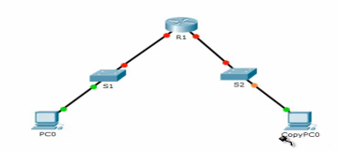

**2.3.2 Procedures**

Step 1: choose a 1941 Router, one 2960 switch, and two PCs

Step 2: select the switch and copy one

Step 3: rename the switch display name to S1 and S2. You can do so by

(1) click the display name of the switch; or

(2) click the switch, and then go to the Config tab, change the Display Name)

Step 4: change the Hostname to S1 and S2. You can do so by

(1) click the switch and go to Config tab, change Hostname to S1 and then Save the change. At the bottom part there is a window called “Equivalent IOS Commands”, which show you how to change the host name in the command line. Please use those commands for the other switch.

(2) use command to change host name. Click the switch, go to CLI tab, click Enter in the IOS Command Line Interface window. Then, typing in following commands:

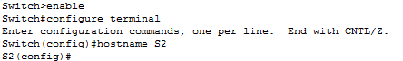

Step 5: Change the display name of the router to R1

Step 6: Configure the first PC. Click the PC and then go to Config tab

Under the Global setting, enter the Gateway IP address 192.168.1.1

Go to the FastEthernet0 (the interface), enter the IP address 192.168.1.2 and use the default mask: 255.255.255.0

Step 7: Configure the second PC. Click the PC and then go to the Desktop tab, click IP Configuration

Enter IP address: 192.168.2.2, use default mask 255.255.255.0

Default Gateway: 192.168.2.1

Step 8: Connect PC0 to S1

Click Connections, then choose Copper Straight-Through

Connect PC0 FastEthernet0 to S1 FastEthernet 0/1

Step 9: Connect switches and Router (S1 and R1, R1 and S2)

Click Connections, then choose Copper Straight-Through

Use S1 GigbitEthernet 0/1 to connect R1 GigbitEthernet 0/0

Use R1 GigbitEthernet 0/1 to connect S2 GigbitEthernet 0/2

Step 10: Connect PC1 to S2

Click Connections, then choose Copper Straight-Through

Connect PC1 FastEthernet0 to S2 FastEthernet 0/1

Step 11: Go to the router, CLI tab

Change hostname to R1 by using commands

C:\Users\75LCUI\AppData\Local\Temp\1493399571(1).png

Configure the IP address for GigbitEthernet 0/0 to 192.168.1.1 by using following commands:

C:\Users\75LCUI\AppData\Local\Temp\1493399662(1).png

Configure the IP address for GigbitEthernet 0/1 to 192.168.2.1 by using similar setting

Step 12 (FINAL STEP): Checking whether the network is established correctly or not. If the network is successfully built up, PC0 and send and receive messages to and from PC2. ping is a command to test whether to end devices can talk to each other or not. Therefore,

go back to PC0, go to the Desktop tab, and click Command Prompt

enter ping 192.168.2.2

if you get following figure, everything WORKS!

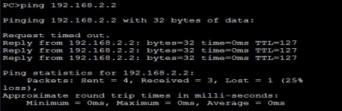

A little bit explanation, the first “request timed out” is due to the resolving of ARP. If you typing in the command ping 192.168.2.2 for the second time, no “request timed out” will be displayed, since ARP is already resolved.

**3. Lab**

Step 1: Build up a topology with one router, two switches, four PCs. See figure below.

PC0 FastEthernet0 connect Switch0 FastEthernet 0/1

PC1 FastEthernet0 connect to Switch0 FastEthernet 0/2

PC3 FastEthernet0 connect Switch1 FastEthernet 0/1

PC4 FastEthernet0 connect to Switch1 FastEthernet 0/2

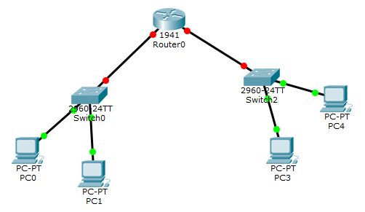

Step 2. Name Router0 to R1, Switch0 to S1 (both display and host name), Switch2 to S2 (both display and host name).

**Show the configuration in Global setting for the router and two switches.**

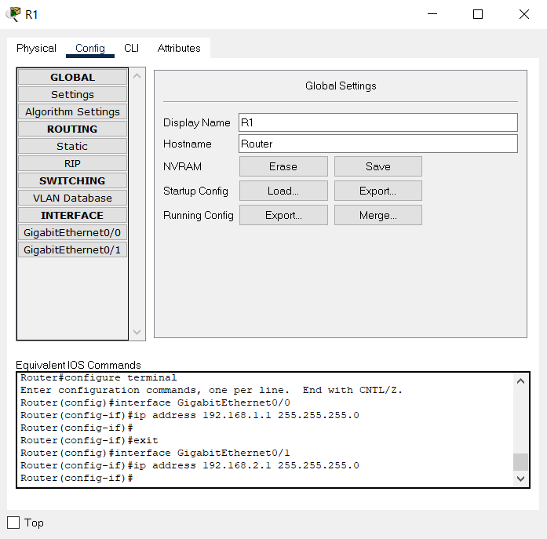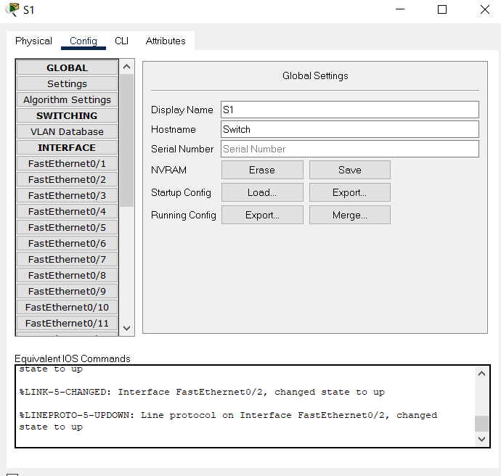

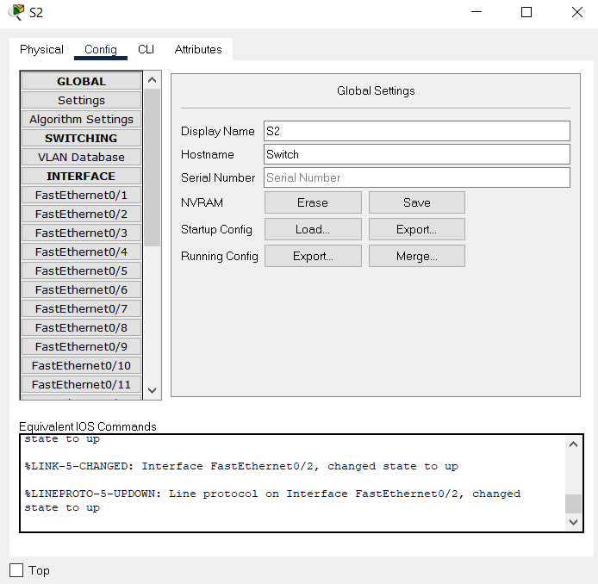

**Show the topology with correct display name**

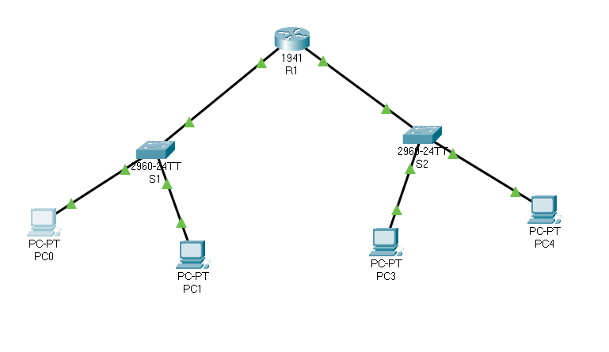

Step 3: Configure IP addresses and default gateway

|  |  |  |  |
| --- | --- | --- | --- |
| Devices | IP address | Mask | Default gateway |
| PC0 | 192.168.1.2 | 255.255.255.0 | 192.168.1.1 |
| PC1 | 192.168.1.3 | 255.255.255.0 | 192.168.1.1 |
| PC3 | 192.168.2.2 | 255.255.255.0 | 192.168.2.1 |
| PC4 | 192.168.2.3 | 255.255.255.0 | 192.168.2.1 |
| R1 interface GigbitEthernet 0/0 | 192.168.1.1 |  |  |
| R1 interface GigbitEthernet 0/1 | 192.168.2.1 |  |  |

**Show the ip address of PC1 and PC4 by using ipconfig /all command in Command Prompt**

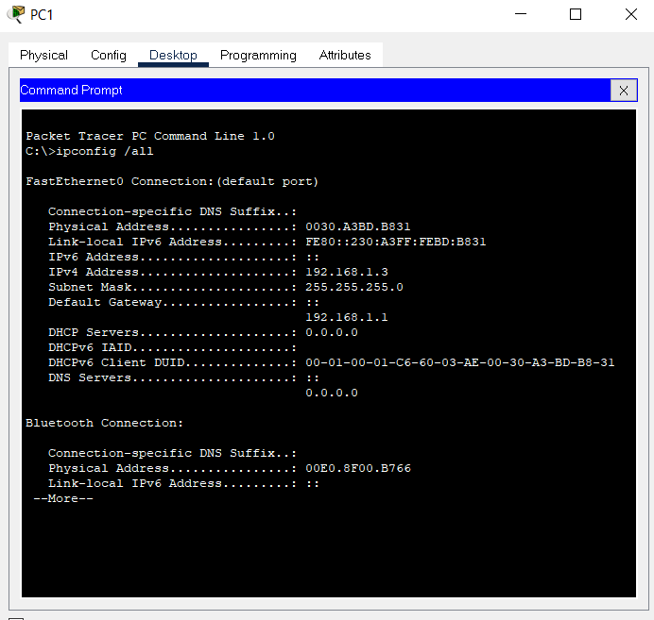

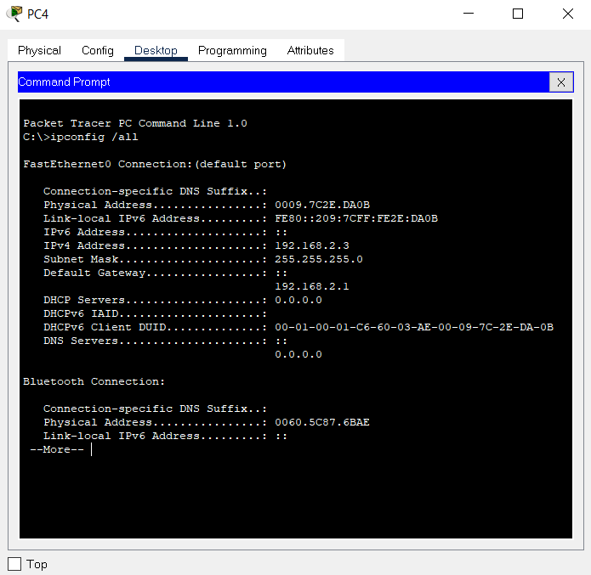

Step 4: Verification.

**Show PC0 can send and receive messages from PC1 and PC4.**

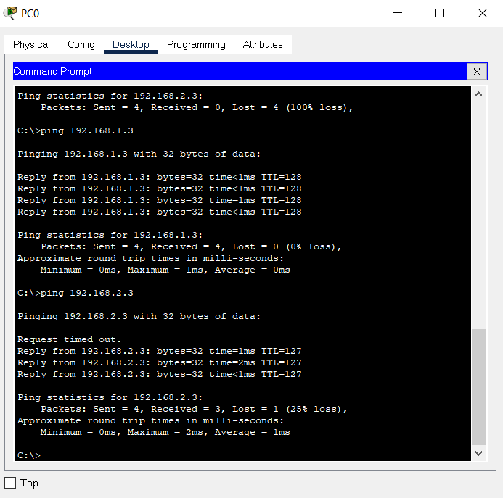

**Can’t get the message between PC0 and PC1 or PC0 and PC4?**

No problem! One thing that we want to learn in the network labs is trouble shooting.

If you cannot reach from PC1 and PC0. You may want to check the configuration on PC1, PC0, and switch0.

If you cannot reach from PC1 and PC4, let’s further isolate the problems. Several tests you may want to try are:

* ping from PC1 to R1 interface 192.168.1.1—check PC1, switch, and R1 configuration if fails
* ping from PC1 to R1 interface 192.168.2.1—check R1, switch, and R1 configuration if fails
* ping from PC3 to PC4 –check PC3, PC4, and switch if fails

Also, don’t forget the turn on the port. They are not automatically on.